IB_Direct

V4.015 Beta

DRAFT
Friday, July 31, 2026

DISCLAIMER:
This software is provided on an “as is” basis.
Although it has been carefully tested, errors are always possible
as it is NOT possible to anticipate all eventualities
in a chaotic, uncertain world…

Prerequisites & Recommendations 3
Introduction 4
Starting the IB_Direct program 4
The IB_Direct main dialog 6
System menu 6
Ticker area 8
Entry/Exit Buttons 8
Function Buttons 9
Order Type and Size 10
Financial Advisor Settings 11
Order Status 1 11
Order Status 2 12
Connecting to IB 13
Status 13
On the TWS side 14
On the IB_Direct side 14
Settings 17
Settings details 18
Paper Trading 19
Log File 19
Registry 19
Trading with IB_Direct 20
Ticker 20
Order Management 20
Adjusting stop/limit prices (primary order) 21
Canceling an order 22
Attached Stop/Limit Orders 22
Canceling Stop/Limit Orders 23
Last word 24
Some Troubleshooting tips… 25

Prerequisites & Recommendations
- IB_Direct v4 relies heavily on the MS Windows™ Registry to store many default parameters as well as current order information in case of interruptions such as PC failure, IB stoppage, or Internet connection problems. Please always check for any possible registry corruption or Windows issue with adequate utility program.
- The IB TWS works within the Java Run-Time environment. It is highly recommended to upgrade to the latest Java Virtual Machine (currently v1.6 with or without SDK)
- Java and the TWS can use up a substantial amount of RAM. To ensure there isn’t excessive paging, RAM specs are as follows:
Minimum: 256MB (Recommended: 512MB or more)
- The latest IB API must be first installed. However, the IB API is almost in permanent beta stage, and is very poorly documented. This has not made programming around it very easy. At this time, the current version works with API V8.8 (May 2006). Please note that the API interface sometimes changes radically with a seemingly minor update, and may cause IB_Direct to stop functioning. In such rare events, please downgrade to the previous API until I fix the IB_Direct calls according to the new interface. One can only hope the API interface will soon stabilize.
- If the API Setup does not automatically register the TWS.OCX, the program will crash upon loading the main form. Please register it manually the following command: “regsvr32 C:\JTS\ActiveX\Tws.OCX” (you may have to change the path according to actual location).
- The program setup may require the .NET framework from Microsoft. It is usually installed along with Windows XP but can also be downloaded separately at http://msdn.microsoft.com/netframework/downloads/updates/default.aspx . IB_Direct requires the following files which are bundled in the setup file: MFC70.DLL, MSVCI70.DLL, and MSVCR70.DLL (or later versions). Please contact me in case the setup program does not install them correctly.
- It is essential to fully understand how orders are processed at IB for the exchange being traded. Users should therefore read carefully the following page: http://www.interactivebrokers.com/html/webhelp/TWS_Reference_Information/Order_Type.htm
- Lastly, although not required, a multiple screen setup is recommended.

Introduction
The ultimate purpose of the IB_Direct program is to handle signals coming from an automated trading system and send orders automatically to IB through the TWS Java console. Its functionalities are more straightforward than this (too) long document may suggest.
The IB_Direct program in the current version is not yet linked to an external signal source, hence orders are entered manually into the IB TWS at a click of a button hence allowing fast safe simple trading (scalping strategy). While the TWS Java console(s) need to be running along with IB_Direct, they can be minimized as IB_Direct represents the essential trading “dashboard”.
The user interface has been designed to be as intuitive as possible. I have tried my best to keep it as simple and as uncluttered as possible…
This walk-through guide will start with running the program and describe its program design and layout. As we go along, it will then explain in details how to handle different order set-ups.

Starting the IB_Direct program
When the program starts, the user is prompted to enter the number of IB TWS (local or remote) consoles he will wish to connect to. 3 concurrent IB accounts (i.e. 3 separate TWS instances) can be linked at this time.

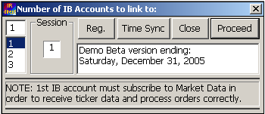
Fig 1
(Layout may change in final release)
What do we see on this screenshot (Fig1 on page 3)?
- On the left side is a list box where to select the number of IB accounts the user wishes to link to. That number of IB accounts (1, 2 or 3), like most settings in the program, is saved as default in the Windows™ Registry. As displayed above in the dialog box, the 1st IB account must have a valid data subscription with IB.
- An IB_Direct session id or session number has been added. This allows to fully separate settings in the Registry in case several instances of IB_Direct run concurrently for different instruments. Each instance can then connect independently to the same IB TWS Java consoles.
- Registration will enable IB_Direct to run permanently after the trial period has expired. A serial code or license will be issued per user on a single PC. This license will also be linked to hardware (HD serial number). This feature is not activated yet in this BETA version.
- This initial form also offers an Internet Time Synchronization (“Time Sync” button) based on the RFC868 protocol. IB_Direct must be firewall-enabled to connect to the Internet Time Server (time.ien.it by default). The time sync may take some time depending on connection speed and server availability. It is run in a different thread which can be interrupted if necessary. When time is returned from the Internet Server, system time is also updated on your PC (admin privileges are required with Win2K, Win XP).
- The program also checks for the API version. It will display an alert if an upgrade is required, and then close. The current IB_Direct build works with the last API v8.71 which seems to be quite stable.
- In the final release, this dialog will also display a “Check for Update” button.
On rare occasions, it may be necessary to clear all registry settings. Such option has been added to the system menu (program icon at top left corner of the window). A major program release may also force automatic reset of those settings to predefined default values.
When ready, just press “Proceed”, or the Enter key to continue.
The IB_Direct main dialog
After pressing “Proceed”, the main IB_Direct form should now be displayed as shown below. Its footprint has been substantially reduced from earlier versions.
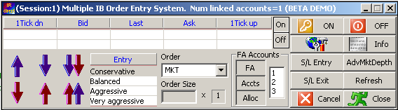
Fig 2 (Actual layout may change slightly in final release)
In a nutshell, the above dialog is composed of a ticker area, order buttons (arrows), program menu buttons, and optional info area at the bottom.
Before describing these various elements on this main form, let’s first take a look at the system menu (top left icon on the main dialog above), to which a few custom items have been added.
System menu
- “Settings”, “Connect” and “Disconnect” are just function copies of the buttons on the main dialog form.
- “Reset buttons status” has been left while debugging the program, and may be of use in some rare occasions. In normal trading operations, an entry/exit button is disabled after being clicked in order to avoid entering multiple positions by mistake. In some cases, a trader may however also want to scale the current position up or down. The program has not been fully tested for this trading mode though. On many occasions, new features have been coded to see them added to the API a few months later. Let’s hope IB will do something about this functionality.
- “Enable/disable order button control”. As said above, one may choose to disable buttons to make sure that an exit always follows an entry.
- “Clear Order Ids in Registry” will reset recorded order Ids. It may sometimes be needed particularly in the situation where the user has placed/cancelled orders directly into the TWS, thus creating a possible discrepancy in order numbering.
- “Clear Connect Ports”: if a connection to the TWS fails for any reason, the ports settings can be cleared here instead of closing IB_Direct altogether. By default, IB_Direct will always connect through the same ports, e.g. 7496 for TWS1, 7497 for TWS2, 7498 for TWS3.
- “Clear All Registry Settings”. Same as on the initial dialog, all registry settings can be cleared here.
- “Return to MKT order type”. When one enters a trade Limit or Stop, one may forget to reset order type to Market, which seems sensible in case one wants to get quickly out of a position. If this option is ticked, order type will be reset to MKT on fill confirmation of STP or LMT entry order.
- “Request IB news bulletins”. There are several levels of news bulletins which can be sent to the Info/Status window if so desired. A dialog is displayed to select the filter level.
- “Set Log Level”. IB info stored in c:\jts folder for debugging or recording purposes. This info is not modified in any way by IB_Direct. In case of a query to IB (no fill, bad fill, late market fill, etc…), this log file can be sent to IB as is for enquiries.
- “Window stays on top”
- “About IB_Direct”
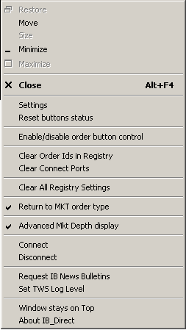
Let’s now take a closer look at the main elements now displayed:

Ticker area
The upper left list containing prices is the ticker received in real time from IB.
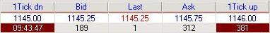
Fig 4
The ticker starts automatically upon connection. Bid, Ask and Last prices are displayed, along with 1 Tick Up and 1 Tick Down prices. Double-clicking a price sets a limit price for the next order (order type is also changed to LMT). For instance, a double click on the Bid price (1145.25) followed by a Buy will send a “BUY 2 ES LMT 1145.25” order to IB. This will be explained again later in this document.
The ticker can be stopped using the On/Off buttons if deemed distracting. The ticker is however required in most cases, unless one chooses to trade market orders only (quick scalping, reversal strategies for instance).
The time displayed on the left is the last ticker update. The figure on the right (381) is the number of contracts or shares traded in the last minute. It may be an indication of low trading activity. Please note however that volume reported by IB does not always seem to tally with volume figures reported by other data sources. This situation may improve now that IB also provides data streams through the API (since v8.50).

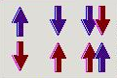
Entry/Exit Buttons
Entries and exits use the same buttons as shown here (arrows):
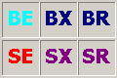
They can alternatively be displayed by acronyms (below). In doubt, all buttons have context tips (mouse hover). The acronym version is disabled at present, but it can be reinstated if arrows seem confusing.
BE is Buy Entry. BX is Buy Exit. BR is Buy Reverse (exit long then entry short), etc…
In order to make sure entries or exits are not duplicated, only allowed buttons are enabled by default. IB would otherwise for instance let you enter into a buy by pressing SX twice. In case of a bug, or to override this feature, button status can be reset in the system menu.
Please note that pressing the order button is in a way a confirmation of any prior setting, particularly the Order Type and Price for Stop or Limit orders. There is no added confirmation box here. In other words, everything has first to be correctly defined. This particularly applies to Limit and Stop entries or exits.
Settings remain unchanged after the order is sent through, i.e. by default a Bid/Ask type entry will be followed by a Bid/Ask exit. You may however want to enter limit and exit market. It is actually recommended to revert back to Market order once entry has been filled and manage the open position with optional attached stop and limit orders.

Function Buttons
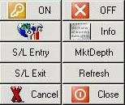
Fig 6
These buttons are placed on the right of the main dialog.
- ON and OFF are connection buttons to the IB TWS.
- The next button below with tools displays the Settings dialog (opened automatically upon valid connection to the TWS).
- “Info” displays the Status / Info window.
- “S/L Entry” displays a modeless form where the user can set or adjust Stop/Limit entry price(s)
- “S/L Exit” displays a modeless form where the user can set or adjust Stop / Limit exit prices. It is recommended to exit a position that way.
- MktDepth or AdvMktDepth display additional information about the order book. AdvMktDepth can be used to place / amend orders. Since most trading operations can be carried out from the AdvMktDepth features, a specific section is available later in this document.
- “Refresh” sends a message to IB to refresh the open order status.
- “Cancel” as its name says, cancels the currently pending open order.

Order Type and Size
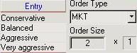
Order type is defined with the list box (see right).
Valid order types vary according to exchanges, and IB will in most cases offer a simulated order type if not supported natively by the exchange.
Order types currently supported by the API are:
- MKT in IB_Direct
- MKTCLS relevant to institutional clients only
- LMT in IB_Direct
- LMTCLS relevant to institutional clients only
- PEGMKT relevant to institutional clients only
- STP in IB_Direct
- STPLMT in IB_Direct
- TRAIL in IB_Direct
- LIT in IB_Direct
- MIT in IB_Direct
- REL coded in IB_Direct, but not activated
- VWAP may be added in the future
Order construction does not differ significantly according to its type, so it should be relatively easy to add new ones if so desired. Please always check the selected order type is supported by the exchange and instrument traded.
LIT (Limit if Touched) and MIT (Market if Touched) are the latest additions to IB_Direct.
Like STP and LMT orders, LIT and MIT require trigger prices. To make sure the user does not forget, the entry price dialog pops up when LIT or MIT order type is selected.
Default order size is defined in “Settings”.
Order size could also be amended on the main form, but this feature is seldom used, so has been disabled in BETA version. In most cases, one will choose to select a type of entry to increase order size.
A very simple rule is here used, i.e. a simple multiplier:
- Conservative: use default order size
- Balanced: 2 X default order size
- Aggressive: 3 X default order size
- Very aggressive: 4 X default order size
Like order size, such multiplier cannot of course only be modified while in position.

Financial Advisor Settings
Some settings are available on the main dialog form. These core functionalities have been extracted from IB sample code, and should work OK. They however could not be tested using the IB demo account.

Order Status 1
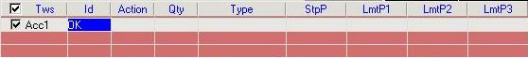
The next display area is the order status 1 list control. This part of the dialog is hidden when not in the market. It is possible to visualize it briefly however by pressing the “Refresh” button. Additionally, in order to keep the UI fairly uncluttered, this area actually has several functions:
- When the entry order is filled, it will display the attached stop and limit exit orders, with current total position and exit prices.
- When the order is not filled yet (stop/limit entry), it displays the pending order details submitted to IB.
One must understand that this list is a container for order status messages sent back by IB. Since those messages have to fit on one line only (per TWS), on some occasions, they may supersede (or erase) a previous message (if unrelated), or complete a previous message (for instance, limit exit submission message after stop loss exit submission message pertaining to the same entry)
Usage notes (UI):
- Clicking on the Order Status 1 list refreshes the open order status. Unlike the “Refresh” button, this applies to any status change from orders initiated on IB_Direct only. The “Refresh” button calls for a status update on all open orders for the current symbol, including those made directly on the TWS.
- Double-clicking the Order Status 1 list clears the list.
- Right-clicking the Order Status 1 list allows for cancellation of open orders (both pending entry/exit and attached exit orders).
- It is possible to select which account(s) to include or not for next orders to come (this does not apply to existing orders in the market, i.e. cannot be used to cancel orders). The TWS1 cannot be excluded.
This option must be with extreme caution as it may quite difficult to follow orders sent on such or such TWS.

Here is an example (Fig 5) of a long position with 1 stop and 2 limit exit orders:
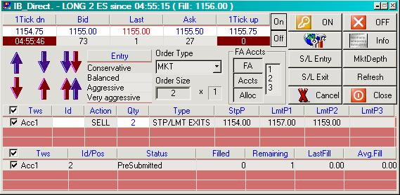
Fig 5
The status list shows stop and limit exit orders for a total of 2 contracts. In this case, 2 contracts will be sold at 1154 STP (StpP), 1 contract will be sold 1157 LMT (LmtP1), 1 contract at 1159 LMT (LmtP2). It is a “display only” area: Exit orders cannot be modified here.
Please note that identical orders are always sent to all enabled IB accounts (check box). If an account is disabled, following later positions may be very difficult. This feature should therefore be used with extreme caution.

Order Status 2
The bottom list displays the last order status retrieved from IB. Upon fill, up to 6 attached orders (3 stops & 3 limits) can be sent, so the returned status info will come in bursts, and only the last item can be here displayed. All information is however recorded on the Status/Info window (Fig7) as well as in the log file.
This list is more useful to check the status of a pending primary order (i.e. stop/limit entry or exit)
Possible values include:
- PendingSubmit - indicates that you have transmitted the order, but have not yet received confirmation that it has been accepted by the order destination.
- PendingCancel - indicates that you have sent a request to cancel the order but have not yet received cancel confirmation from the order destination. At this point, your order is not confirmed canceled. You may still receive an execution while your cancellation request is pending.
- PreSubmitted - indicates that a simulated order type has been accepted by the system and that this order has yet to be elected. The order is held in the system (and the status remains DARK BLUE on the TWS) until the election criteria are met. At that time the order is transmitted to the order destination as specified (and the order status color will change).
- Submitted - indicates that your order has been accepted at the order destination and is working.
- Cancelled - indicates that the balance of your order has been confirmed canceled by the system. This could occur unexpectedly when the destination has rejected your order.
Please check on the IB web site for possible updates (also see order types).

Connecting to IB
Before going any further with this process, it is important to present an important feature in the IB_Direct program: the “Status” window.

Status
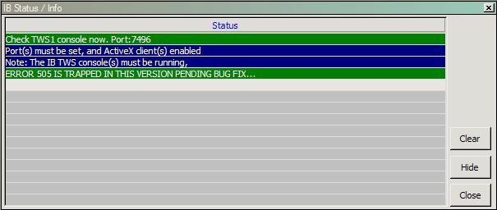
Fig7
The status list is a small window adjustable in size, where all major events will be shown (new lines come on top). Errors will be displayed in Dark Red. Warnings are displayed in Green, and general info in Blue.
This window has an “always on top” flag, but it can be hidden. It can also be extended width-wise if the message is too long to display.
Let’s now look at the connection procedure.

On the TWS side
An IB TWS Java console must be running for each IB account being traded, and ActiveX clients must be enabled (see below). TWS windows can be minimized since they should not be needed during trading. Memory usage should not increase significantly with more than one IB account, as only one Java Virtual Machine is running.
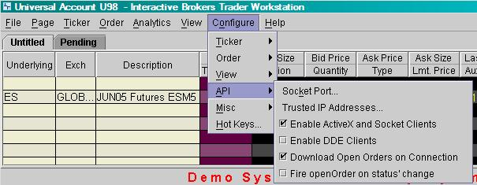
(TWS layout is likely to change)
Warning: please note the IB TWS having been first designed to handle single accounts, running several TWS consoles may be a little tedious at first. IB_Direct will always associate each TWS to a definite port. It is recommended to always open the several TWS consoles in the same order and check their default socket port. The ticker will be called from TWS 1.
Open orders and positions are always checked by IB_Direct. The “Download Open Orders on Connection” setting may not really matter, but it is recommended to leave it on.

On the IB_Direct side
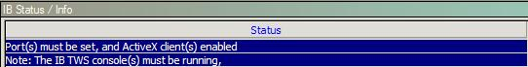
Press the “Connect” button to link to the TWS. Connecting is actually a local system process, since the TWS is the Java program which will handle the communication over the Internet with the server at IB.
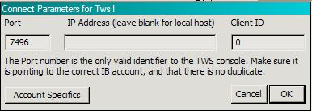
The Port number must of course coincide with the socket parameter that has been set in the TWS configuration.
The IB_Direct program may be running on a different machine than the TWS through IP channeling if needed. If the IP field remains blank, it is assumed that the TWS is located on the same PC (IP “local host”), otherwise please enter the IP address of the computer running the TWS in question. The remote TWS may however be protected behind a firewall, so please check your router settings as it may be necessary to open a router port. The port number to open is the same as the TWS socket number. This of course should not apply if the IP address is located on the same LAN i.e. if the connection is made between computers behind the same firewall.
The client Id is generally irrelevant for individual accounts. The program relies entirely on authentication as handled by the TWS, and the only valid link identifier per se is the Port number (7496 in the example above). However, Client Id can also be used to allow several instances of IB_Direct to connect to the same (local or remote) TWS, to trade different instruments for instance.
The option “Account Specifics” makes it now possible to trade a different number of contracts/shares for each IB account. Caution should be exercised here, particularly if fractional exits are used. Other account specifics may be added in a future version.
Press OK when ready.
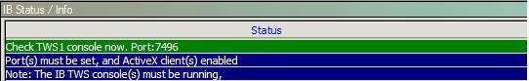
A message appears in the Status window, asking you to acknowledge the connection request on the IB TWS window. The only response from IB, when connected, is the next valid order id which may then be used in the system. Order ids are handled automatically by simple increment within the program. As you will see, when stop and limit orders are used, the main entry order number is immediately followed by the stop order(s) and limit order(s) numbers.
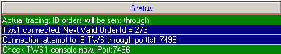
Connect / Disconnect does not use a toggle button as one might first expect. The reason is that it is better to handle multiple connections this way. If a connection to an individual TWS drops, it can be restarted by clicking the Connect button without affecting other running TWS. Disconnecting does not reset connection ports. Ports can be cleared by restarting the program or from the system menu.

Settings
The Settings dialog will appear automatically upon successful connection to the TWS. Please refer to IB Help page for further details.
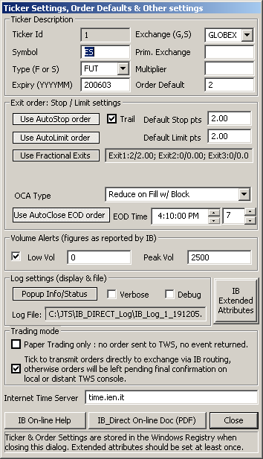
(Layout may change slightly in final release)
It can also be later called from the system menu or by clicking the toolbox button.
Settings are sent to IB upon closing this dialog, so while settings can be consulted off-line, they are only truly valid upon successful connection to IB.
In most instances (particularly day trading futures), little will need be changed here except maybe for default stop/limit points, and the contract expiry. All settings are saved in the Windows Registry. The above settings are OK for ES e-mini. The Extended Attributes do not really need to be modified at this stage (see IB documentation for details).
Only 1 ticker is used at present (i.e. only 1 instrument is traded). Please note that the TWS only serves as a “Java” gateway to IB, i.e. the broker. The ticker being selected does not have to be defined in the TWS, although it is most advisable to do so to check orders are correctly built and transmitted.

Settings details
The ticker frame includes all minimum settings required to trade either futures or stocks. It does not however cater for options at this stage. Order construction is basically the same, so it should not be a problem to add options specifics to this form if needed.
In most cases, IB orders are routed through GLOBEX for futures or SMART for stocks. Primary exchange and multiplier are to be left blank for futures (new addition to the API v8.3).
The exit order frame includes details for attached OCA orders. In normal trading situations, an entry will be covered on both sides by a stop loss order and one or several limit orders (up to 3 fractional exits). Stop orders can either be fixed or trailing. A unique price is used for all stop orders. OCA orders will be described in details later in this document.
An option has been added to force exit on End-Of-Day, specified by a set time (local exchange time + time offset). “Market on Close” orders are generally not accepted for retail customers, hence have not been coded in this program. Again, order construction would be virtually identical, so this could be added if need be. A forced EOD exit does about the same, although processed differently at IB.
Volume alerts can be used to signal low volumes or sudden bursts in volume (as reported by IB).
BETA VERSION: levels of Verbose and Debug logging may change until final release.

Paper Trading
As its name suggests the “Transmit orders to IB” checkbox allows orders to be stopped at the TWS for confirmation. One could think of using it to for instance distribute signals to remote TWS consoles (through the IP address attached to the port number), where the recipient user would vet the final decision on the TWS itself.
It is therefore not quite an alternative to paper trading with the IB demo account (account: edemo, password demouser). When using the paper trading option, orders are not generated at all but are displayed in the status window and recorded in the log file. As such this cannot emulate fills.
Please note that the IB demo account does not provide accurate market data. It is most recommended to log in and open a paper trading sub-account on the IB web site.

Log File
Most events are recorded in a log file stored in a C:\JTS sub-folder.
For example: “C:\JTS\IB_DIRECT_Log\IB_Log_1_210405.txt” will contain details for Session 1 on April 21st, 2005.
A specific order log file is also created in the folder “C:\JTS\IB_DIRECT_LogTrade\”.

Registry
For your information, all settings recorded when closing the “Settings” form, are stored in the HKEY_LOCAL_MACHINE, SOFTWARE section of the Registry under the IBDn key (n being the session number) under the following sub-keys:
- Connect
- DefaultSettings
- LastOrders

Trading with IB_Direct
We have now described most of the program’s user interface. We are now connected to IB. It is time to trade with it…
If the program has been run at least once, just to check the various forms, the connection to the IB TWS, as well as the ticker, then all settings have now been stored in the registry. Subsequent uses of the program will possibly require less attention as all previous settings will be restored automatically.

Ticker
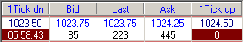
The ticker has been already briefly described in the introduction. Bid/Ask/Last Trade price and volumes are displayed in real time. Time of the last ticker update and accumulated volume in the last minute bar are also shown (dark red background boxes). One generally avoids trading when volume per minute drops below 1000 (ES e-mini).
Clicking on the ticker bar can be used as a simple shortcut for limit entries. The selected price is set to be used in the next limit order (entry or exit), and Entry Type changes to Bid/Ask Limit (for Bid/Ask price) or Limit (for 1 Tick down or 1 Tick up). The Entry Type list box gives the same entry/exit options, but also includes the Stop-Limit entry/exit. Please note that the price itself is not recorded at that point. If Bid or Ask is updated before the order button is pressed, the last current price will be used.
Clicking on “Last” reverts to “Market” order type. It is recommended to do so, as one may sometimes have to exit quickly from an adverse position. Alternatively, the System Menu includes an option to always return to market type order after a stop or limit entry.
If the ticker is not active, double-clicking the ticker opens the “Settings” dialog.

Order Management
IB_Direct is connected, ticker and order settings are defined, and the ticker is running. Everything is now ready to place an order.
The order buttons have already been described. Placing an order is therefore quite straightforward. We however recommend to practice placing orders with the IB demo account for a while to become familiar with the order status and other messages received from IB.
Let’s assume an order is sent to IB. In this first example below, it is a “BUY 2 ES 1147.75 LIMIT”. Prices have started moving up, so we may consider increasing the limit price in case we anticipate the order not to be filled.

Adjusting stop/limit prices (primary order)
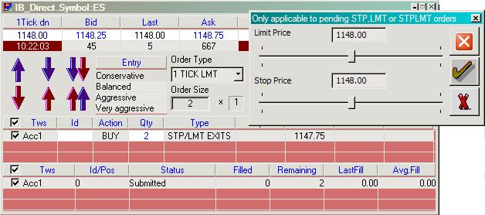
(Layout may change in final release)
If the current entry/exit pending order is STP, LMT, LIT, MIT or STOP-LIMIT, and has not been filled yet, price can be updated. Pressing the “S/L Entry” button displays a modeless form on which such price(s) can be modified using the slider control. Changing Order Type (1 TICK LMT on previous screenshot) also displays the “S/L Entry” price setting dialog.
The required entry price can be now set, with or without closing the dialog. The pending order can also be cancelled altogether here too (“red cross” button).
Obviously, this price adjusting feature is not applicable to a market order which is (meant to be) instantaneously filled. Users who want to experiment STOP-LIMIT orders should refer to the IB documentation to make sure which the right trigger method may be used (may not be applicable to GLOBEX). A word of caution is needed at this point: stop orders are not always native orders on the exchange being trader. Although this should work just as well on simulated stop orders, discrepancies may occur (actually often on the IB demo accounts). The STOP-LIMIT trigger method can be set in the Extended Attributes settings.
Changing a LMT price has no effect on a STOP order. Reversely, changing a STP price has no effect either on a LIMIT order.
Please note that this setting can be applied to both entries and exits. It must be used with caution for reversals. A reversal to short is made of an exit long followed by a sell short. A Bid/Ask limit reversal will therefore built as a Sell Ask followed by Buy Bid which may be difficult to fill, and relatively inefficient for a reversal which is usually meant to be quickly executed.
Lastly, it is possible to set a limit exit order by clicking a price on the ticker, pressing the buy exit or short exit button and possibly adjusting it later as described above. It is however recommended to instead use attached exit orders for that purpose (see below).

Canceling an order
This may sound obvious, but it is clear that only STP or LMT or LIT or MIT or STOP- LIMIT unfilled orders can be cancelled, as MKT orders are executed immediately (cancellation is not synonymous to closing a position). The “Cancel” button applies to primary orders (i.e. not attached stop/limit orders).
Please note that order cancellation may take some time to show on the TWS and on IB_Direct.

Attached Stop/Limit Orders
Stop loss and Limit target orders can be attached to the primary order (see “Settings”), and it is always most advisable to do so.
In the current version of IB_Direct, up to 3 stop and 3 limit orders can be generated. The 3 stop orders are set at the same price, and are each linked to a corresponding limit order in a separate OCA group. This allows keeping the right balance (current position) in open orders, i.e. when the 1st limit is hit and filled the attached stop is cancelled immediately. Please note that being an OCA group, everything is handled at IB servers, so this is quite safe to use should anything happen locally.
Price can be adjusted anytime while not filled by pressing the “S/L Exits” button, which displays a modeless dialog. Order updates are generally carried out within a fraction of a second. Updating exit levels is the main trading tool to maximize profit (limit) and minimize risk (stop) while in position.
Unfilled attached orders cancel each other when one is filled (OCA), or are all cancelled on normal exit/reversal.
Here is an example where an entry order has been filled and 2 limit orders have been generated with their corresponding stops (i.e. 2 OCA groups). The 3rd Limit order area has been disabled since irrelevant.
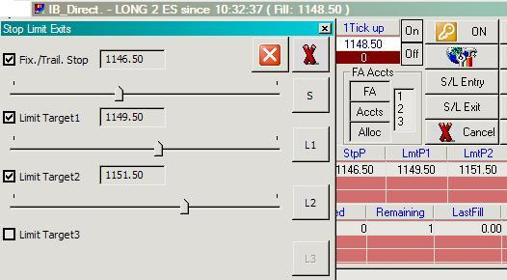
(Layout may change in final release)
The sliders have a set increment equal to the tick size, which is quite appropriate for futures. Each order can be adjusted separately, in case an overall update would in certain cases reset the position of other stop or limit order(s) in the order book.
In the example above, the user selected to have fractional exits (1 stop order, and 2 limit target exits), so the 3rd exit level is disabled.
Each individual button on the right-hand side validates your choice. The other buttons (top right) either update your exit orders or just close the dialog. It is likely that updating exit orders does reset the position in the order book, hence it is recommended to avoid doing so unnecessarily.

A word of caution
OCA orders as the name entails will have all orders in the same OCA group cancelled when one is filled. If the order is however partially filled, the rest of the group disappears, and yet there is no reason to assume the remaining contracts or shares will ever be filled. This may lead to imbalance in the open position. Extreme caution must therefore be exercised here, particularly when the trading is slow or when volume traded is low.
NOTE: API 8.5 now offers different OCA types. The feature is implemented and is offered for beta testing.

Canceling Stop/Limit Orders
On some occasions, it may be desired (or needed) to force the cancellation of an order, for instance to let the last limit order “run”, or the order clean-up failed (OCA error), or any other reason.
To do so, just right-click the Open Orders List 1 and cancel open orders one by one:
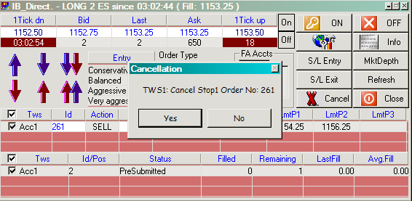
It is recommended to first call for a status refresh to better associate order ids with the corresponding order.

Last word
Every attempt has been made to release this program free of “bugs”. As you have surely understood by now, this program relies on an API which is anything but stable (errors 202 and 505 are still trapped pending updates from IB). In addition, testing it using the demo server has not always been entirely satisfactory (simulated stops are sometimes not operational).
A lot of effort has been put to ensure that information is always saved into the registry in case of momentary PC failure, disconnection. The program should be able to recover from all situations. On normal program exit, recorded information for open positions and pending order is cleared. Testing and feedback will be very much appreciated.
There is a possible remaining issue with partial fills, which has until now also been difficult to test fully. I will try my best effort to ensure trading with IB_Direct is always as safe as possible, with due consideration that it is impossible to cover all eventualities. It has been for instance found during testing that the connection to IB may drop for any odd reason (IB server or Internet connection). Upon automatic reconnection, IB sends a message “Data maintained” whereas orders have in fact disappeared. It is therefore imperative to always monitor open positions. IB_Direct is in my opinion a valuable tool in the direction of automated trading. However, we are still miles away from having the PC trade for you while sipping a daiquiri watching a beautiful sunset…

Happy trading,
bruno voisin

Some Troubleshooting tips…
It is not possible to ensure 100% guaranteed error-free order management. There may be rare cases where orders will have to be modified or cancelled directly on the TWS.
Even if IB_Direct always tries to always keep everything in check on the TWS, discrepancies may happen, and should be reported to me. There is always a slight chance of a bug creeping up in the code, or more likely the user environment may be not tight enough. In such event, it is recommended to cancel the order on the TWS (click-right and close position for instance), and clear all registry settings.

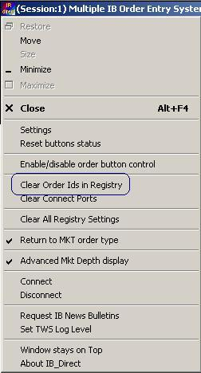

Errors will be very rare. Please try and replicate the error on the IB paper trading account at least twice, then send a detailed log file to support@foretrade.com . It may be a bug, but in most cases, it will be some misunderstanding of the program (poor documentation…) or some issue with the messaging system in IB. This program relies entirely on IB sending the right information at the right time…
Other reported issues or clarifications:
- IB_Direct is by default configured to have all orders covered by opposite stop and limit orders. It is mostly recommended to exit prematurely by adjusting those existing orders instead of creating a new exit order. Orders work in OCA mode, and it is simply far less error prone to close an order group that way instead of generating a new exit order cancelling the previous order group.

Recorded in the HKEY_LOCAL_MACHINE, SOFTWARE section of the Registry
Remote TWS can be accessed via their IP address (a port may have to be opened to access it through a firewall).
Since API v8, IB_Direct now also caters for Advisor accounts. This will allow trading many more accounts through “umbrella” accounts (max 15 per non-professional advisor). In order to keep the UI simple and easy to use, the Advisor function (contract allocation, monitoring individual accounts, etc…) have however not been fully coded in IB_Direct yet (due to lack of demand), but the functionalities are there.
Please note that the number of connected TWS consoles cannot be changed once the main dialog is loaded, but accounts can be momentarily deactivated on the main dialog form if so desired.
Log on to the IB web site for details (exchange fees etc)
Technically IB_Direct will accept simple market orders without an active IB ticker, but this is certainly not the recommended usage.
Please note that news bulletins and logging info are called through the 1st TWS only.
Price changes color if it goes up, down, or stays unchanged.
CAUTION: if button control is disabled, and orders can be inadvertently repeated by pressing an order button twice (or more). Pressing the wrong button, like exit long for a sell short may also have adverse consequences. IB should differentiate both entries (technically it is a SELL for a exit long, and a SSHORT for a sell short) but testing on the IB demo account proved that it does not always do it…
This calls for status update for ALL open orders, including changes made directly on the TWS.
This applies to the primary order, i.e. normal entry or exit, but not the attached OCA exits, which are handled separately.
This slight difference may seem subtle, however one must take in consideration that the TWS may not always be local to IB_Direct. IB_Direct can be used to disseminate signals to one or several remote TWS console(s). In addition, irrespective of its location, the TWS may stop all orders for confirmation.
The Info window will pop up automatically unless this option is disabled in program settings. That window is set to be displayed on top of other windows.
A remote TWS is generally used to separate order management from charting. It can also be used to send orders i.e. signals to a truly remote client. In such case, caution should be exercised as of legal implications regarding actual order management (location vs. origin of decision)
Client Id may or may not be merged with Session No in a future version.
The Status window stays on top of other windows. It can however be minimized. It must be active to record events (even if minimized).
Order Ids are stored in a JTS sub-folder. Hence they should keep being incremented. It is possible to reset the counter by deleting that folder (named “darykq” in current API releases). Deleting that folder will probably also reset all your TWS default settings.
Double clicking the Disconnect button also clears port settings
IB will try and restore the connection. No action needed.
Please note that all orders are valid “DAY” by default, which is the common choice for day-traders. Position traders may want to change that setting to “GTC” (Good Till Cancelled). Other choices are available. See IB Help file for details.
Some settings have not been coded, like GAT (Good After Time). Please refer to the documentation for details.
One Cancels All
A trailing order is a sliding stop order following positive price movement.
For simplicity, a single price is used for all exit limit orders. This may change in future versions, but since a stop loss order should be a “risk of ruin” order and not a trading tool per se, this has considered sufficient.
Sending an order to IB generates immediately a series of follow-up events and messages. IB_Direct repeats a status request to IB after 5 seconds.
Data here shown is incorrect. This is a flaw or limitation from the IB demo accounts, to prevent users from getting actual market data for free…
Primary order means normal entry/exit as opposed to attached OCA exit orders.
Technically, order size can also be updated, but this has not been allowed in this version of the IB_Direct program.
A modeless form does not capture the focus. The user can leave it open and click back to the main form. It is actually recommended to do so until the order is filled.

